Selly Oak Constituency Neighourhood Network Scheme
Small Grants Fund – Local COVID-19 Response Application Form

RETURN TO: Karen.Cheney@birmingham.gov.uk & Ian.Ellis@birmingham.gov.uk

Date: | Your Name and contact details:
Ward/ Neighbourhood | Proposal Title
New grant allocations will be made for community-based support required because of the Covid-19 outbreak
Please describe the Covid-19 Support you are wanting to provide in the neighbourhood and approximate costs

How will your project be implemented?

Please list partners you will be working with and explain their involvement?

Time Frame – is it:
- A one-off event/programme
- Or to be Implement over next 6 months

Main outcome will be the relief or prevention of suffering that is a director indirect consequence of the Covid-19 outbreak
Please list the outcomes along with how they will be measured?

Do you have measures in place to protect your project workers/volunteers in line with Government guidance on COVID-19? If yes, what measures do you have in place?
(e.g. DBS checks for volunteers and/or personal protective equipment if needed)

Project Coordinator Details:
Name:

Organisation:

Telephone (s):

E-mail:

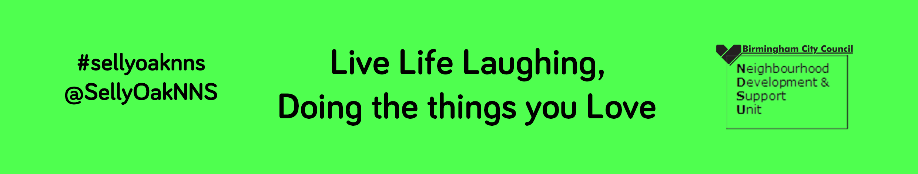

Internal use only
Received: Date:
Go to Decision Panel: Date:
Approved
Yes
No

